SEC Form 3
FORM 3 | UNITED STATES SECURITIES AND EXCHANGE COMMISSION  Washington, D.C. 20549  INITIAL STATEMENT OF BENEFICIAL OWNERSHIP OF SECURITIES  Filed pursuant to Section 16(a) of the Securities Exchange Act of 1934  or Section 30(h) of the Investment Company Act of 1940
  OMB APPROVAL
  OMB Number: | 3235-0104
  Estimated average burden
  hours per response: | 0.5
1. Name and Address of Reporting Person*  (Street) | 2. Date of Event Requiring Statement (Month/Day/Year)  10/05/2026 | 3. Issuer Name and Ticker or Trading Symbol  Tenable Holdings, Inc. [ TENB ]  Foreign Trading Symbol
  Bell Charles H
  (Last) | (First) | (Middle)
  C/O TENABLE HOLDINGS, INC.
  6100 MERRIWEATHER DRIVE
  COLUMBIA | MD | 21044
  (City) | (State) | (Zip)
 |  | 4. Relationship of Reporting Person(s) to Issuer  (Check all applicable) | 5. If Amendment, Date of Original Filed (Month/Day/Year)
   | Director |  | 10% Owner
   | Officer (give title below) |  | Other (specify below)
6. Individual or Joint/Group Filing (Check Applicable Line)
Form filed by One Reporting Person
Form filed by More than One Reporting Person

Table I - Non-Derivative Securities Beneficially Owned
1. Title of Security (Instr. 4) | 2. Amount of Securities Beneficially Owned (Instr. 4) | 3. Ownership Form: Direct (D) or Indirect (I) (Instr. 5) | 4. Nature of Indirect Beneficial Ownership (Instr. 5)
Table II - Derivative Securities Beneficially Owned
(e.g., puts, calls, warrants, options, convertible securities)
1. Title of Derivative Security (Instr. 4) | 2. Date Exercisable and Expiration Date (Month/Day/Year) |  | 3. Title and Amount of Securities Underlying Derivative Security (Instr. 4) |  | 4. Conversion or Exercise Price of Derivative Security | 5. Ownership Form: Direct (D) or Indirect (I) (Instr. 5) | 6. Nature of Indirect Beneficial Ownership (Instr. 5)
1. Title of Derivative Security (Instr. 4) | Date Exercisable | Expiration Date | Title | Amount or Number of Shares | 4. Conversion or Exercise Price of Derivative Security | 5. Ownership Form: Direct (D) or Indirect (I) (Instr. 5) | 6. Nature of Indirect Beneficial Ownership (Instr. 5)
Explanation of Responses:
Remarks:
No securities beneficially owned. Exhibit List - Exhibit 24 - Power of Attorney
No securities are beneficially owned.
 | /s/ David Bartholomew, Attorney-in-Fact | 10/06/2026
 | ** Signature of Reporting Person | Date
Reminder: Report on a separate line for each class of securities beneficially owned directly or indirectly.
* If the form is filed by more than one reporting person, see Instruction 5 (b)(v).
** Intentional misstatements or omissions of facts constitute Federal Criminal Violations See 18 U.S.C. 1001 and 15 U.S.C. 78ff(a).
Note: File three copies of this Form, one of which must be manually signed. If space is insufficient, see Instruction 6 for procedure.
Persons who respond to the collection of information contained in this form are not required to respond unless the form displays a currently valid OMB Number.
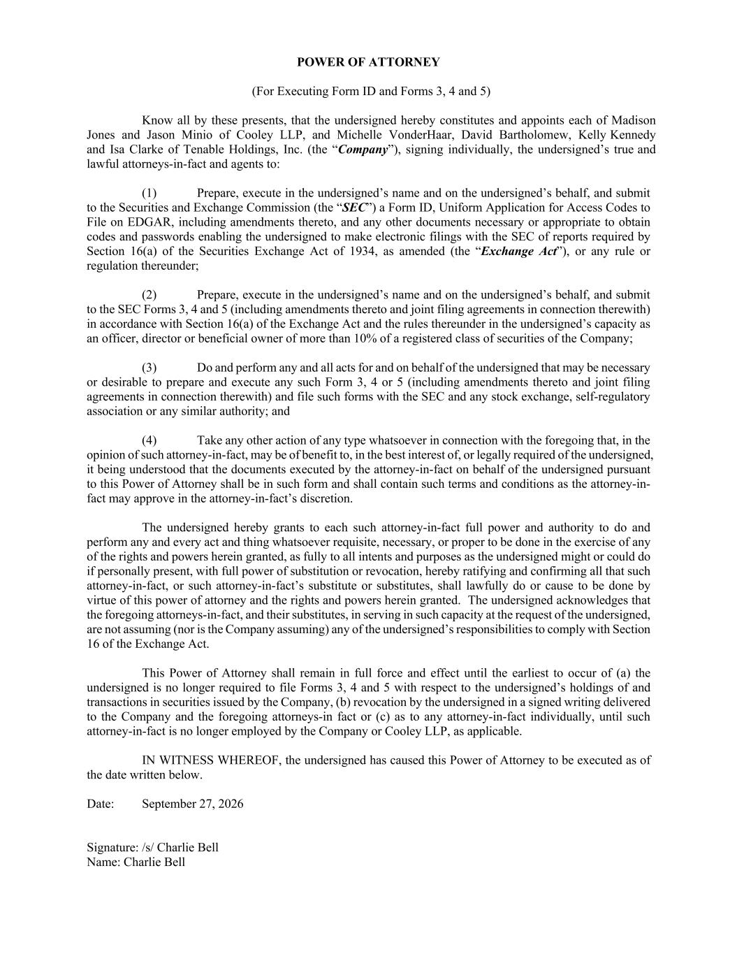
POWER OF ATTORNEY (For Executing Form ID and Forms 3, 4 and 5) Know all by these presents, that the undersigned hereby constitutes and appoints each of Madison Jones and Jason Minio of Cooley LLP, and Michelle VonderHaar, David Bartholomew, Kelly Kennedy and Isa Clarke of Tenable Holdings, Inc. (the “Company”), signing individually, the undersigned’s true and lawful attorneys-in-fact and agents to: (1) Prepare, execute in the undersigned’s name and on the undersigned’s behalf, and submit to the Securities and Exchange Commission (the “SEC”) a Form ID, Uniform Application for Access Codes to File on EDGAR, including amendments thereto, and any other documents necessary or appropriate to obtain codes and passwords enabling the undersigned to make electronic filings with the SEC of reports required by Section 16(a) of the Securities Exchange Act of 1934, as amended (the “Exchange Act”), or any rule or regulation thereunder; (2) Prepare, execute in the undersigned’s name and on the undersigned’s behalf, and submit to the SEC Forms 3, 4 and 5 (including amendments thereto and joint filing agreements in connection therewith) in accordance with Section 16(a) of the Exchange Act and the rules thereunder in the undersigned’s capacity as an officer, director or beneficial owner of more than 10% of a registered class of securities of the Company; (3) Do and perform any and all acts for and on behalf of the undersigned that may be necessary or desirable to prepare and execute any such Form 3, 4 or 5 (including amendments thereto and joint filing agreements in connection therewith) and file such forms with the SEC and any stock exchange, self-regulatory association or any similar authority; and (4) Take any other action of any type whatsoever in connection with the foregoing that, in the opinion of such attorney-in-fact, may be of benefit to, in the best interest of, or legally required of the undersigned, it being understood that the documents executed by the attorney-in-fact on behalf of the undersigned pursuant to this Power of Attorney shall be in such form and shall contain such terms and conditions as the attorney-in- fact may approve in the attorney-in-fact’s discretion. The undersigned hereby grants to each such attorney-in-fact full power and authority to do and perform any and every act and thing whatsoever requisite, necessary, or proper to be done in the exercise of any of the rights and powers herein granted, as fully to all intents and purposes as the undersigned might or could do if personally present, with full power of substitution or revocation, hereby ratifying and confirming all that such attorney-in-fact, or such attorney-in-fact’s substitute or substitutes, shall lawfully do or cause to be done by virtue of this power of attorney and the rights and powers herein granted. The undersigned acknowledges that the foregoing attorneys-in-fact, and their substitutes, in serving in such capacity at the request of the undersigned, are not assuming (nor is the Company assuming) any of the undersigned’s responsibilities to comply with Section 16 of the Exchange Act. This Power of Attorney shall remain in full force and effect until the earliest to occur of (a) the undersigned is no longer required to file Forms 3, 4 and 5 with respect to the undersigned’s holdings of and transactions in securities issued by the Company, (b) revocation by the undersigned in a signed writing delivered to the Company and the foregoing attorneys-in fact or (c) as to any attorney-in-fact individually, until such attorney-in-fact is no longer employed by the Company or Cooley LLP, as applicable. IN WITNESS WHEREOF, the undersigned has caused this Power of Attorney to be executed as of the date written below. Date: September 27, 2026 Signature: /s/ Charlie Bell Name: Charlie Bell

